Section A
- What is the name of the functional group found in carboxylic acids?
Tick ( ) one box.
- Hydroxyl | 
- Carboxyl
- Ethanoxyl

- What is the formula of the functional group found in alcohols?
Tick ( ) one box.
- OH
- OCO
- COOH

- A polyester can be made from the reaction between molecules of ethandiol and hexanedioic acid.

- How many carbon atoms would be found in hexanedioic acid?
_______________________________________________________________________________________________

- Complete the displayed formula for a molecule of ethandiol.

C C

- Name the type of reaction that would occur when many molecules of ethandiol reacted with many molecules of hexanedioic acid.

_______________________________________________________________________________________________

- Name the other product that would be formed in this reaction.

_______________________________________________________________________________________________
Section B
- The picture below shows a surfboarder. Surfboards are made from different polymers.
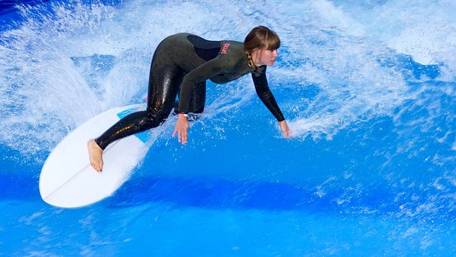

The core of a surfboard is made from poly(styrene). A section of the displayed formula of poly(styrene) is shown below.
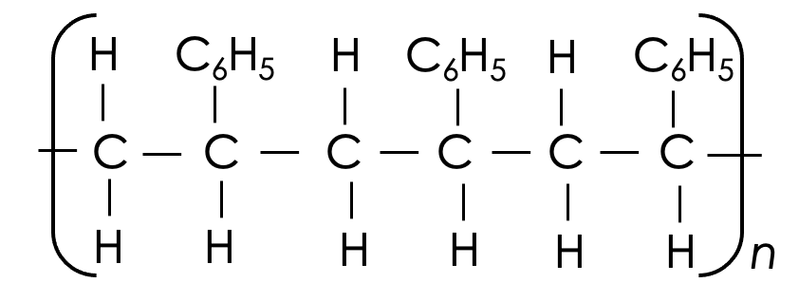

- Complete the displayed formula to show the monomer that poly(styrene) is made from.

C C

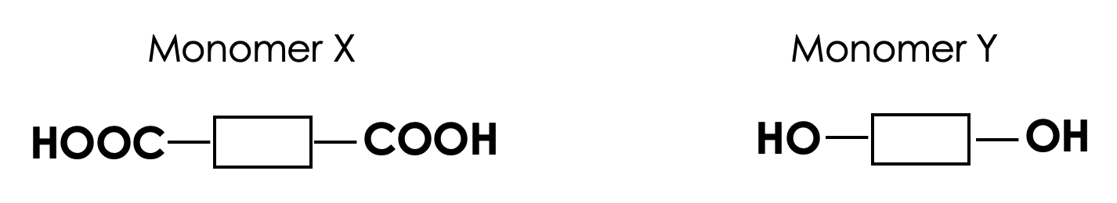
The outer layer of a surfboard is made from a polyester. This polyester is made from two different monomers, X and Y, which are shown in simplified forms below.
- Name the functional group in monomer Y.
_______________________________________________________________________________________________

- The reaction between monomer X and monomer Y produces a polyester and a small molecule.
State the formula of this small molecule.
_______________________________________________________________________________________________

- The polyester used for the outer layer is much more expensive than poly(styrene). Suggest two reasons why it is used.
_______________________________________________________________________________________________
_______________________________________________________________________________________________
_______________________________________________________________________________________________
_______________________________________________________________________________________________

- The formulae below show different monomers; P, Q and R.
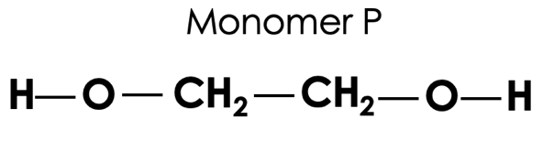
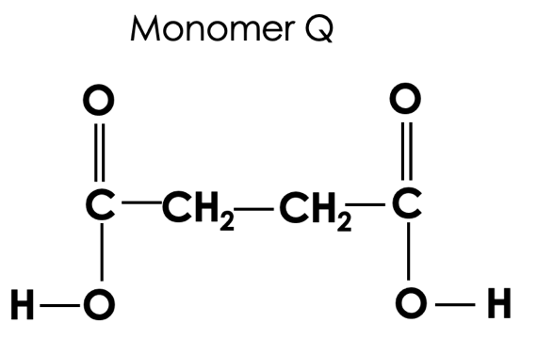

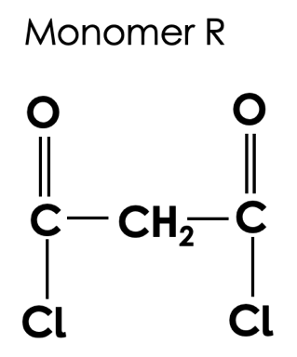

Monomer P can react with either monomer Q or monomer R. In each case, a polymer is produced and a small molecule.

Complete the table to show the small molecules produced in these reactions.

Reactants | Formula of small molecule produced
P and Q
P and R

Section C

- Proteins are naturally occurring polymers formed from amino acids.
- Proteins are synthesised from amino acids through condensation polymerisation reactions. What does this show about the structure of amino acids?
- Name the organelle where proteins are synthesised.
- Give two functions of proteins in the body.
- Explain the effect of a DNA mutation on protein synthesis.

